 | 
Laboratory 9: GPS Integration (ESPHome To Home Assistant Map) | School of Applied Digital Technology
Name:  Name: | ID:  ID: | Section:  Section:
Date: | Due date:

Objectives
- To integrate GPS (latitude and longitude) into smart sensors for location tracking.
- To display sensor positions on Home Assistant’s interactive map.
- To understand how location data can be used for monitoring and automation in IoT systems.

Hardware and Software Requirements
Component | Function
ESP32 DevKit | Main controller board
DHT11 Sensor | Measures temperature and humidity
MQ-2 Sensor | Detects gas concentration
LDR Sensor | Detects light intensity
PIR Sensor | Detects human motion
Fan (Relay-controlled) | Air circulation control
LED | Indicates brightness or darkness
Active Buzzer | Emits sound alarm on gas detection
Home Assistant + ESPHome | Visualization and automation control

Step 1 — Setup and Upload the ESPHome Code
- Use the following ESPHome YAML configuration (no modification needed):
Yaml:
sensor:
# 🌡️ DHT11
- platform: dht
pin: GPIO4
model: DHT11
temperature:
name: "Living Room Temperature"
id: temp_living
accuracy_decimals: 1
latitude: 19.9057
longitude: 99.8355
humidity:
name: "Living Room Humidity"
id: hum_living
accuracy_decimals: 1
latitude: 19.9057
longitude: 99.8355
update_interval: 10s

This configuration enables:
- Temperature and humidity monitoring via DHT11
- Gas detection via MQ-2 sensor
- Light intensity monitoring with LDR
- Motion detection using PIR
- Automatic fan operation when temperature exceeds 30°C
- LED control depending on light intensity
- Gas alarm triggering the buzzer above 0.40V
- Location tracking using predefined GPS coordinates
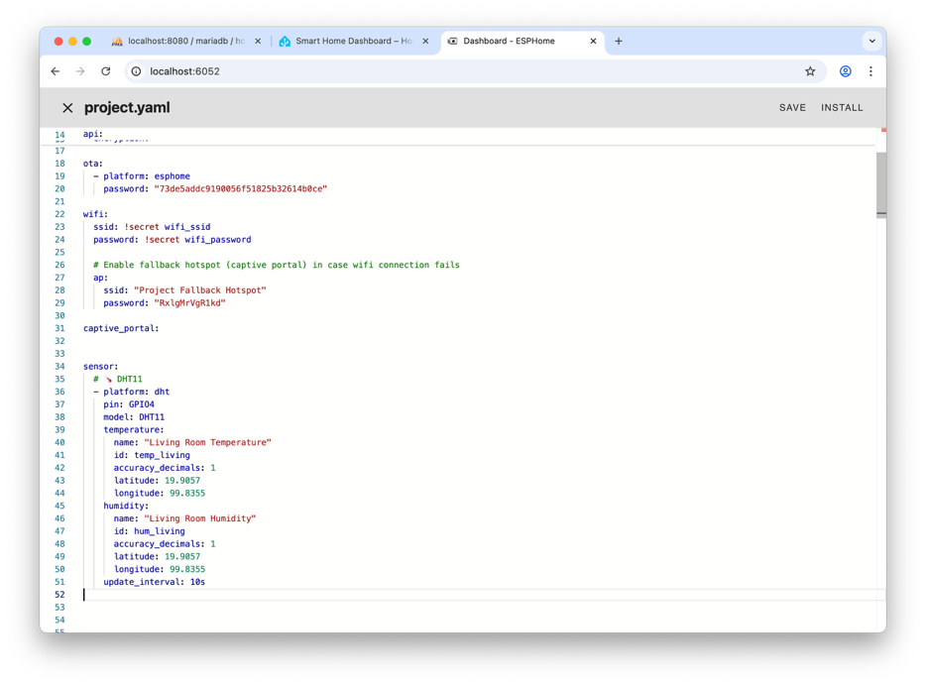

Step 2 — Adding GPS Coordinates for Each Sensor
- Each sensor and binary sensor includes latitude and longitude values.
Example:
Yaml:
temperature:
name: "Living Room Temperature"
id: temp_living
latitude: 19.9057
longitude: 99.8355

- Repeat this for all sensors (DHT11, MQ-2, LDR, PIR) to allow Home Assistant to plot them on a map.

Step 3 — Upload to ESP32
- Open ESPHome inside Home Assistant.
- Click INSTALL → WIRELESS (or via USB).
- Wait for build and upload to complete.
- When successful, ESPHome will show:
✅ Successfully compiled program.
✅ INFO Uploading /config/.esphome/build/project/firmware.bin
- The device should appear Online on the ESPHome dashboard.

Step 4 — Add Map View in Home Assistant
- Add the following card in your Lovelace Dashboard (edit → Add card → YAML):
Yaml:
- type: map
title: "📍 Smart Room Sensor Locations"
default_zoom: 15
entities:
- entity: sensor.project_living_room_temperature
name: "Temperature"
- entity: sensor.project_mq_2_gas_level
name: "Gas Sensor"
- entity: sensor.project_ldr_light_level
name: "Light Sensor"
- entity: binary_sensor.project_living_room_motion
name: "Motion Sensor"
- entity: switch.project_living_fan
name: "Fan"
This displays pins on the Home Assistant map corresponding to each sensor’s coordinates.
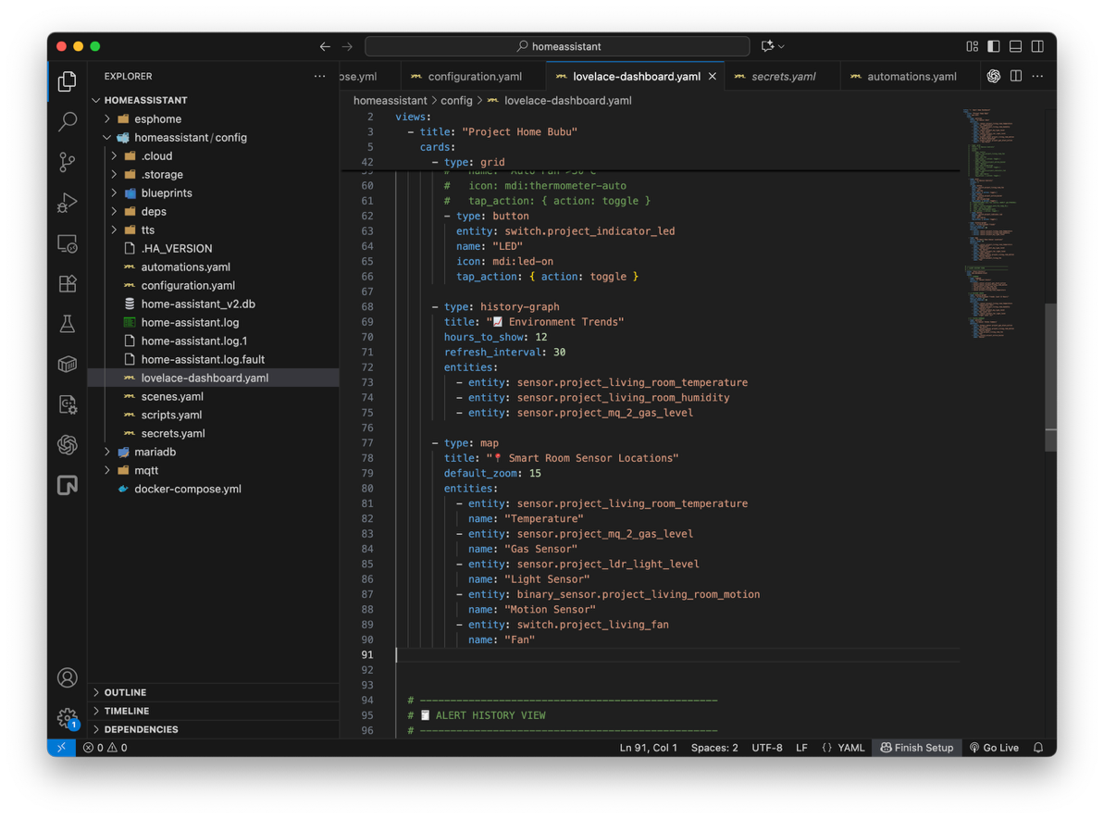
Step 5 — Observation
- The map shows all devices’ GPS positions.
- Clicking a pin displays live sensor values.
- Automatic control works as follows:
  - 🌡️ Temperature > 30°C → Fan turns ON
  - 💨 Gas level > 0.40V → Buzzer turns ON
  - 💡 Light < 1.4V → LED turns ON
  - 🚶 PIR detects motion → “Motion Detected” status changes to ON

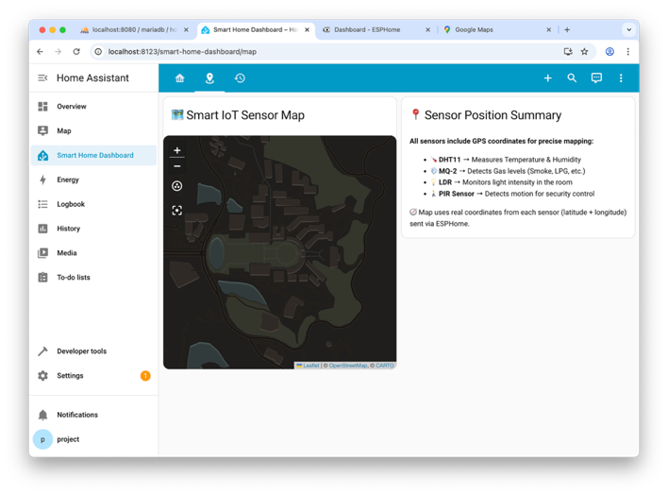
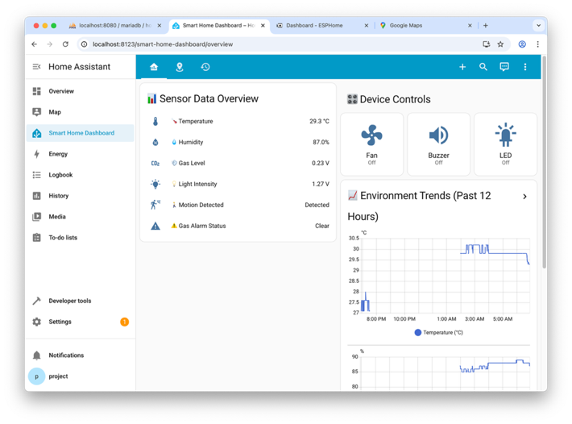

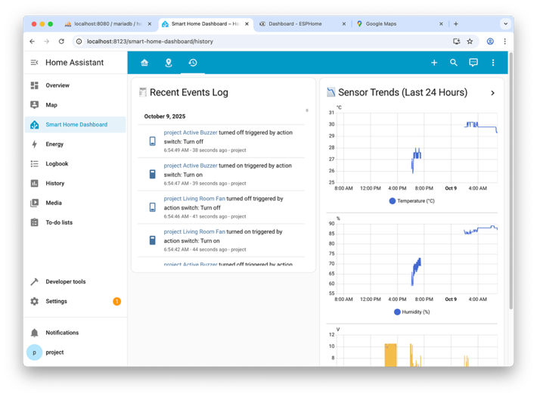

----- Have a good day -----

